## 

## **New Fashion?!… It's Nintendo Society News Time!**

Nintendo@E3 begins on 13th June, and we’ll be live streaming their presentation next week! Hopefully that’s an enticing reward for all the revision and exams this term has put you through!

And with that, here are this week's announcements:

### **New Nintendo Society Clothing**

A report from the Nintendo Society Research Lab informs us of a new upcoming fashion trend:

18765743_1730840656942610_6725651492572826986_n.jpg18622677_1730840653609277_2397497493689820442_n.jpg

A hoodie emblazoned with the society logo and a polo for our dedicated smashers (with optional personalisations for both)! Fascinating! To promote themselves, they have provided a link to purchase these items (and with these specially reduced prices if ordered by Monday 12th June) here: <http://customclubclothing.co.uk/shop/index.php?c=248>



### **Wednesday 7/6, OC1.06, 2pm onwards**

Our weekly Smash event returns! With a possibility of more competitive action! Come along to destress from term 3 revision and have fun!

---------------------------------------------------------------------------------------

Well then, folks, until next time, staaaay fresh!

And Happy Gaming! :D

Timothy Sit

Nintendo Society President

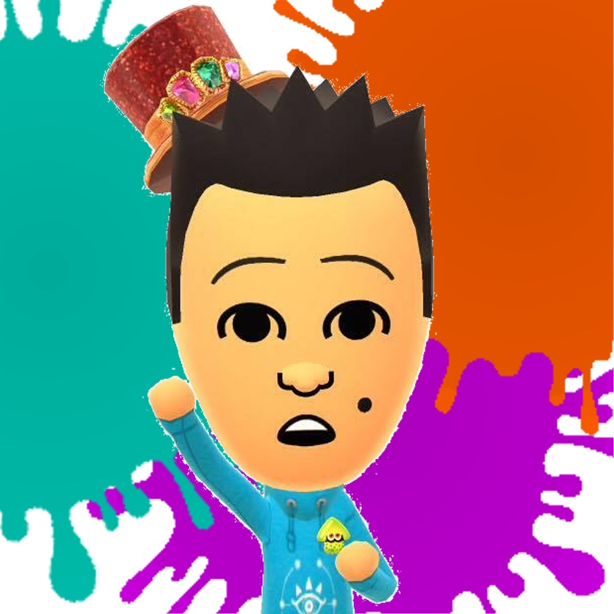

---------------------------------------------------------------------------------------

### **Find us on Social Media:**

Join our Facebook group:<https://www.facebook.com/groups/warwicknintendo/>

Follow our Twitter:<https://twitter.com/warwicknintendo>

Join our Discord Chat:<https://discordapp.com/invite/Rf6QyfG>

Subscribe to our YouTube:<https://www.youtube.com/channel/UCzO_bZNfQDCAQa_zkEUgGVg>